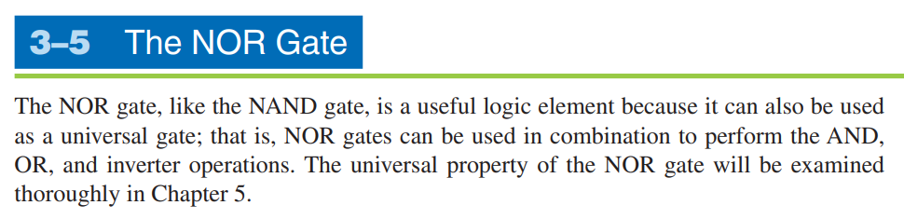

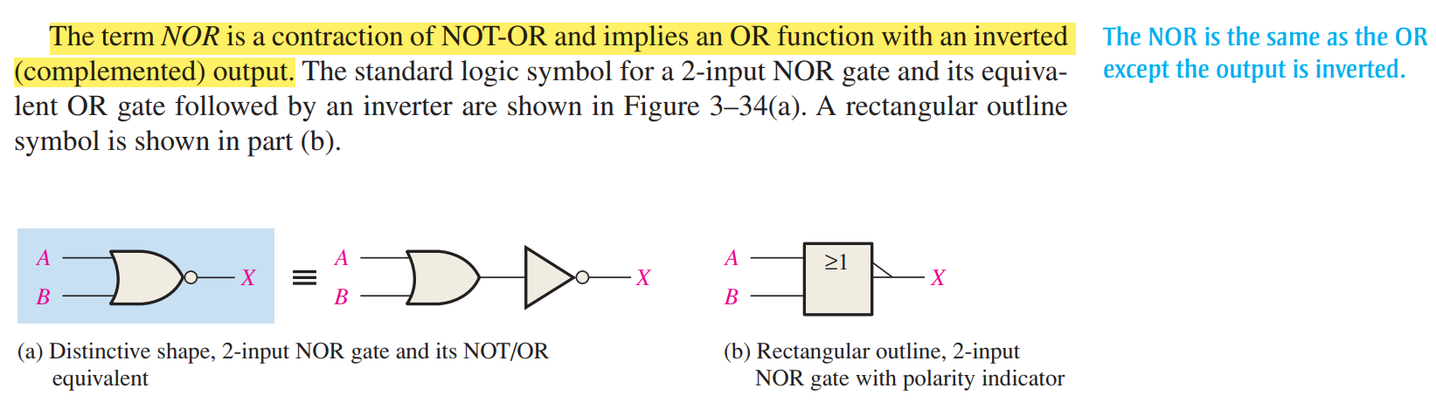

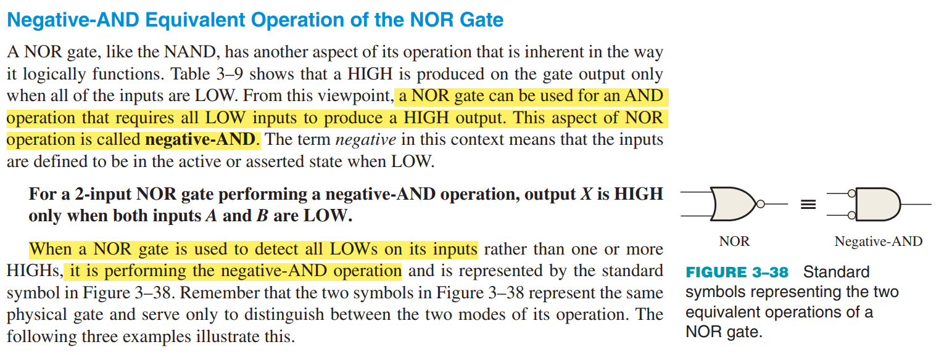

**NAND = Negative – OR**

**NOR = Negative - AND**

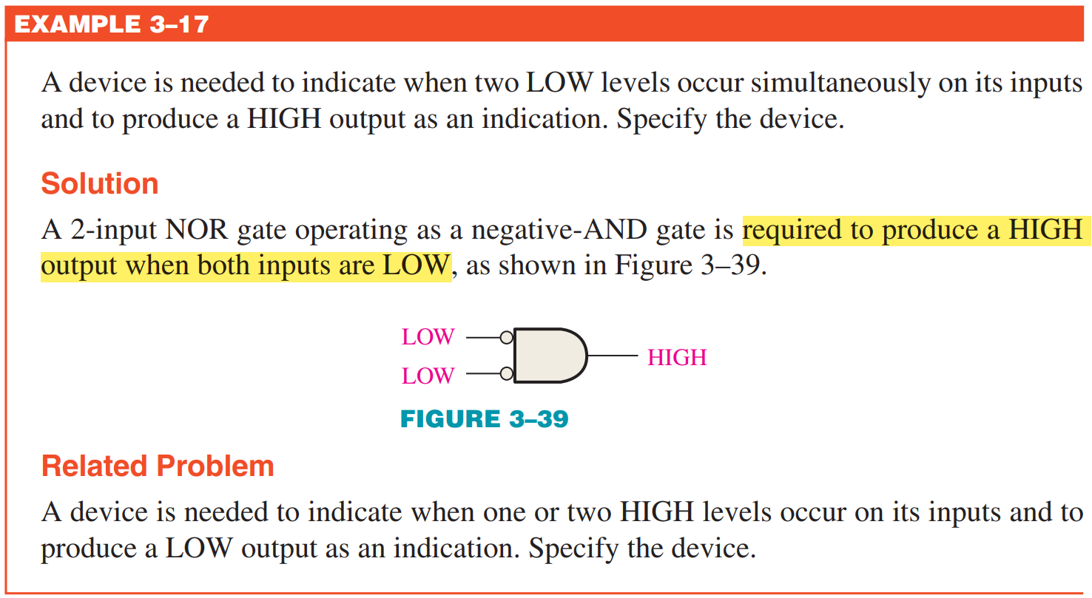

**NOR** gate is used when one or more HIGH input level’s output is desired (LOW).

**Negative – AND** gate is used when all LOW input level’s output is desired (HIGH).

**NAND** gate is used when all HIGH input level’s output is desired (LOW).

**Negative – OR** is used when one or more LOW input level’s output is desired (HIGH).

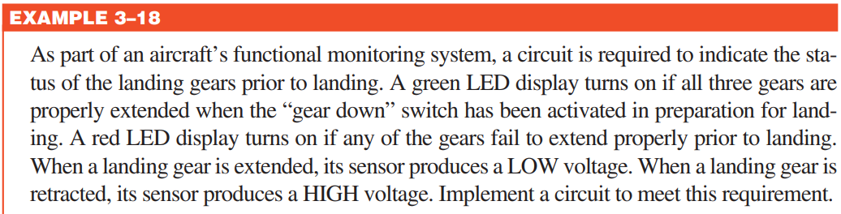

**Airplane Problem**

**INPUTS➡** Extended = LOW = 0 Retracted = HIGH = 1

Green = All Extended = Turns On = HIGH Red = Any failure (Retracted) = Turns On = HIGH

|  |  |  |  |  |  |  |  |
| --- | --- | --- | --- | --- | --- | --- | --- |
| Green | | | | Red | | | |
| A | B | C | X | A | B | C | X |
| 0 | 0 | 0 | 1 | 0 | 0 | 0 | 0 |
| 0 | 0 | 1 | 0 | 0 | 0 | 1 | 1 |
| 0 | 1 | 0 | 0 | 0 | 1 | 0 | 1 |
| 0 | 1 | 1 | 0 | 0 | 1 | 1 | 1 |
| 1 | 0 | 0 | 0 | 1 | 0 | 0 | 1 |
| 1 | 0 | 1 | 0 | 1 | 0 | 1 | 1 |
| 1 | 1 | 0 | 0 | 1 | 1 | 0 | 1 |
| 1 | 1 | 1 | 0 | 1 | 1 | 1 | 1 |
| Negative – AND | | | | OR | | | |

According to the conditions stated in the question, negative – AND gate for Green light and OR gate for Red light, but since we have to connect a battery and a ground with the LED lights, whichever LED is directly connected with the battery, it will only turn ON when it receives a LOW voltage. Let’s say, we want to connect the battery with the Red light, then it will only work when it’s output is inverted, i.e. NOR gate.

HIGH = Turn ON LOW = Turn On

|  |  |  |  |  |  |  |  |
| --- | --- | --- | --- | --- | --- | --- | --- |
| Green | | | | Red | | | |
| A | B | C | X | A | B | C | X |
| 0 | 0 | 0 | 1 | 0 | 0 | 0 | 1 |
| 0 | 0 | 1 | 0 | 0 | 0 | 1 | 0 |
| 0 | 1 | 0 | 0 | 0 | 1 | 0 | 0 |
| 0 | 1 | 1 | 0 | 0 | 1 | 1 | 0 |
| 1 | 0 | 0 | 0 | 1 | 0 | 0 | 0 |
| 1 | 0 | 1 | 0 | 1 | 0 | 1 | 0 |
| 1 | 1 | 0 | 0 | 1 | 1 | 0 | 0 |
| 1 | 1 | 1 | 0 | 1 | 1 | 1 | 0 |
| Negative – AND | | | | NOR | | | |

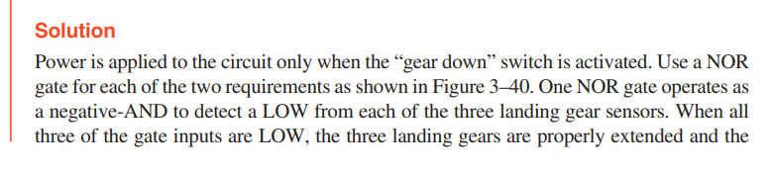

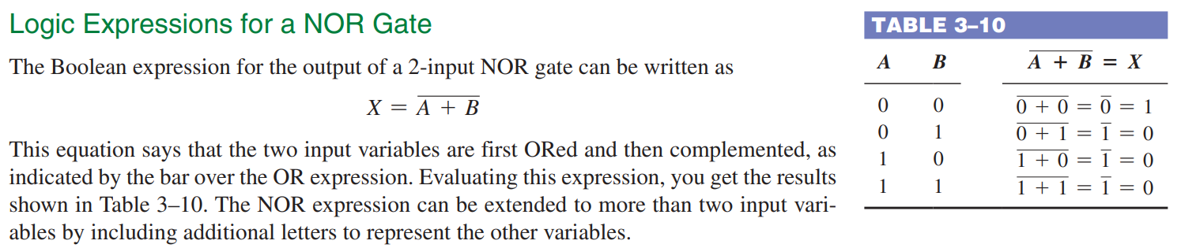

**Describe the functional difference between a NOR gate and a negative-AND gate.**

NOR: active-LOW output for one or more HIGH inputs. Negative-AND: active-HIGH output for all LOW inputs.

**--NOR** gate is used when one or more HIGH input level’s output is desired (LOW).

**--Negative – OR** is used when one or more LOW input level’s output is desired (HIGH).



